CHRISTMAS WORDSEARCHES
Bible wordsearches Christmas words Santa's workshop
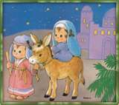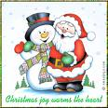
CHRISTMAS GAMES
Games with words Word construction
What's the time? Count the money
Animals The Nutckracker Game
Hangman Christmas and New Year

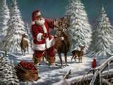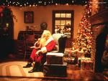

LEARNING VOCABULARY
Different themes Family members
Animals and Environment Memory - Animals
